Steps for creating a EC2 Instance and Setting up DOCKER inside it.

Step 1:- Go in Amazon EC2 click on Launch an instance :-

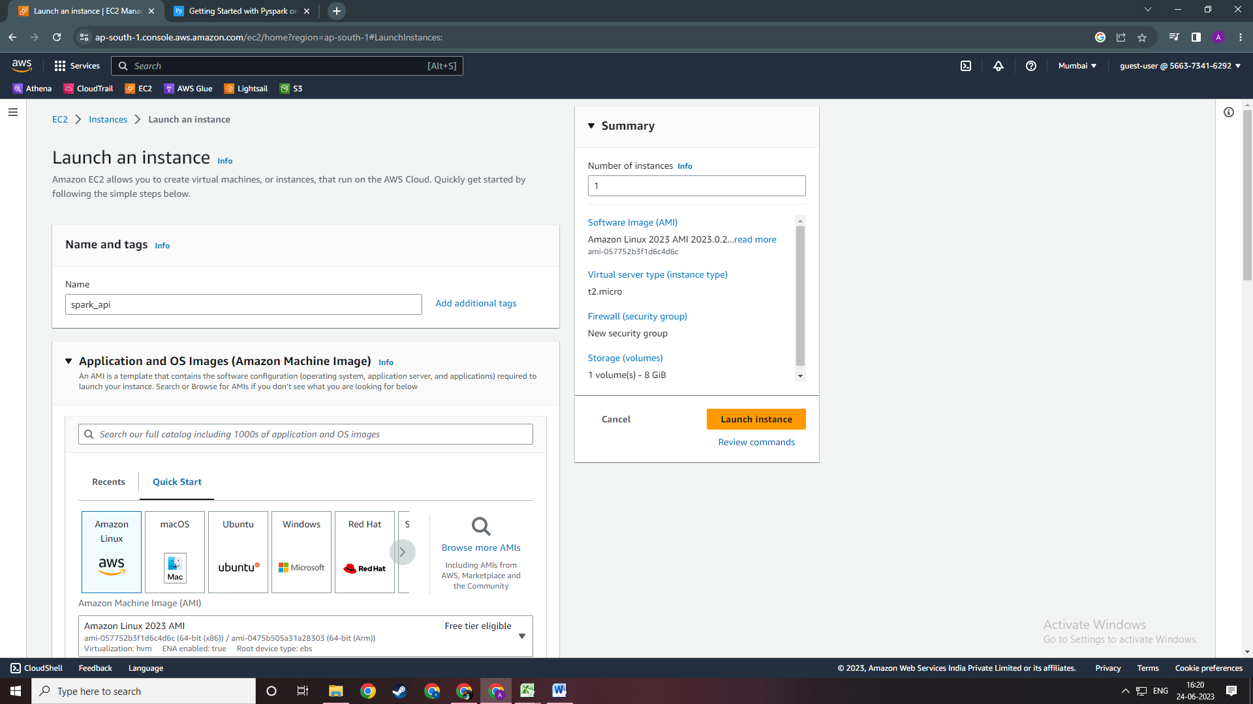

Steps 2:- Select AWS Linus and then Instance Type t2micro as your instance type as shown.   
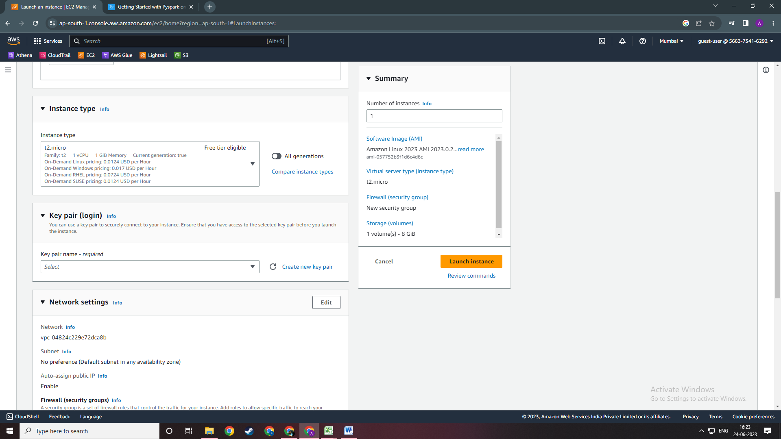

Step 3. Create your own Key pair for your instance by clicking on Create new key pair. Once you click on it you will get this following window . Keep the setting as shown and click on create key pair. It will download a pem file which you need to store it into your desired directory.   
  
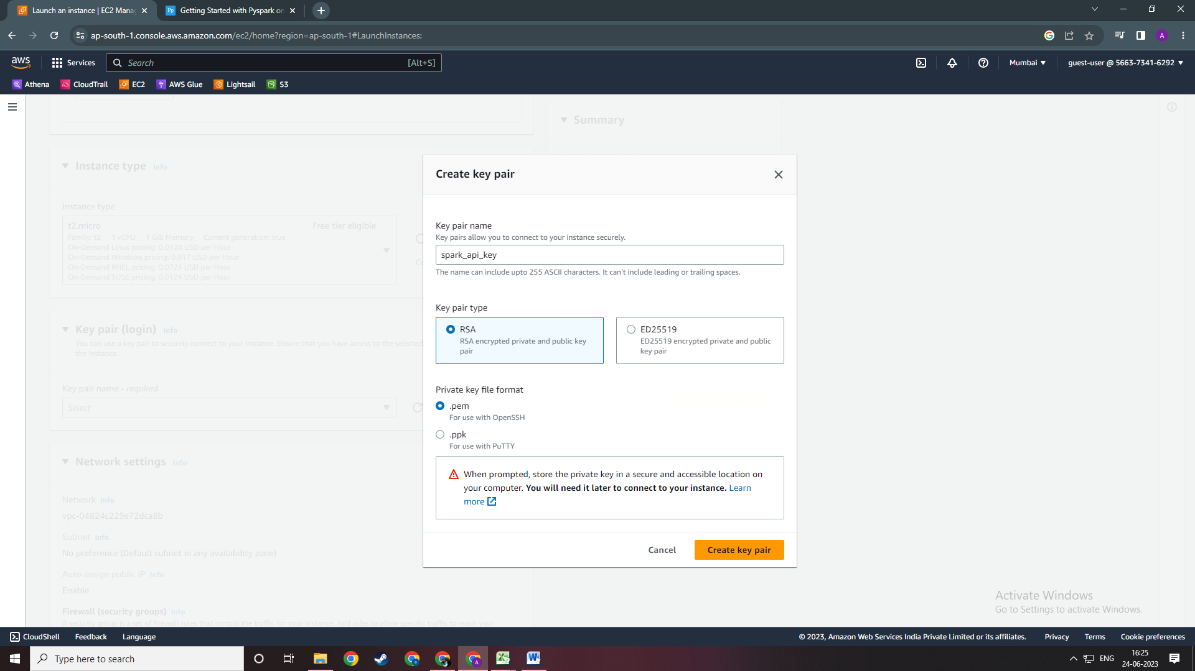

Step 4. After that Don’t change anything keep everything default and click on Launch Instance.

ONCE YOUR instance is up and running and you see this page click on CONNECT in the top right corner.

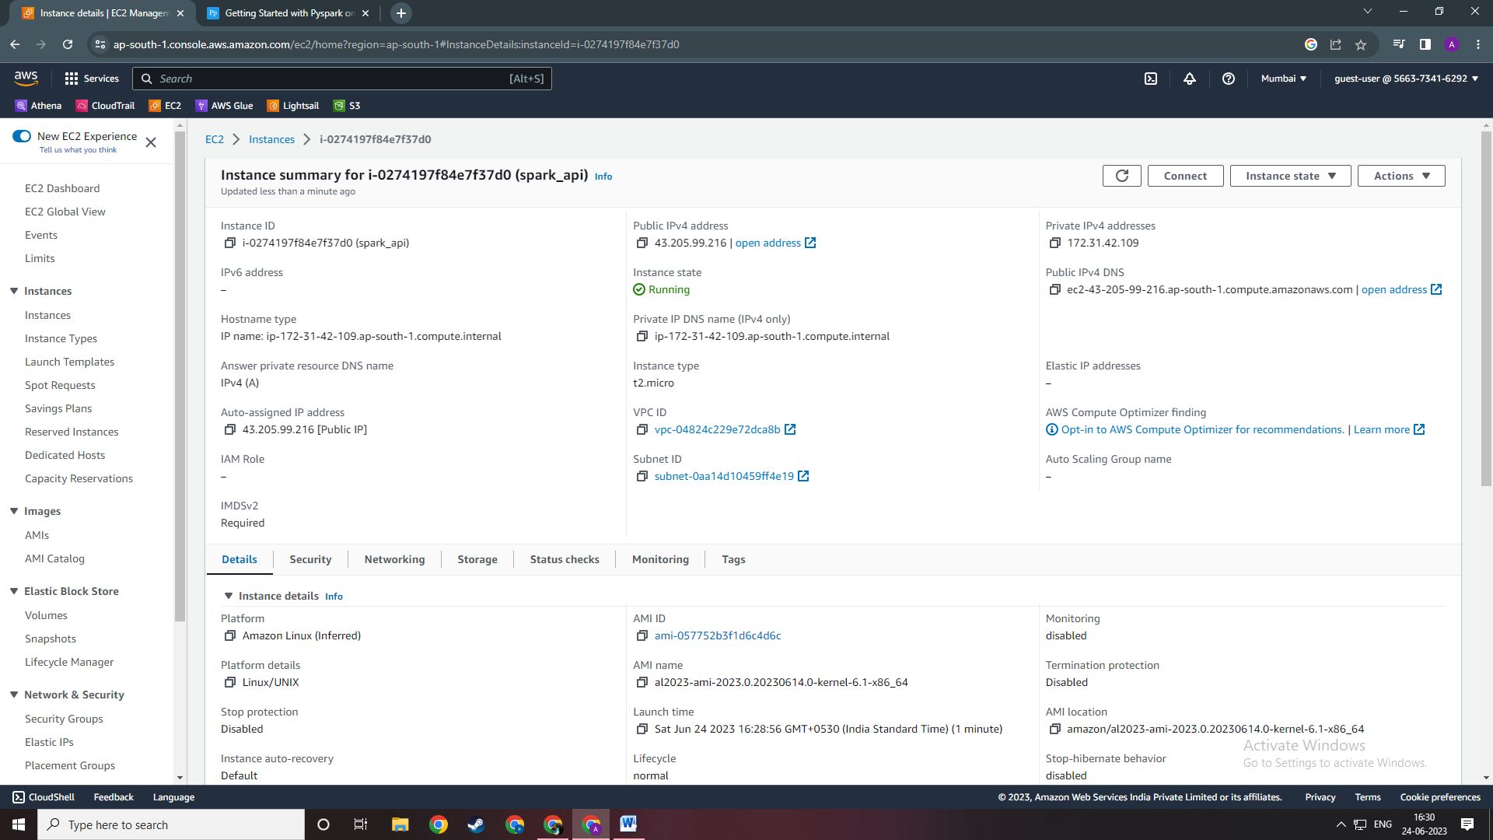

Step 5. After clicking on Connect see that you click on SHH cliet as shown below.  
  
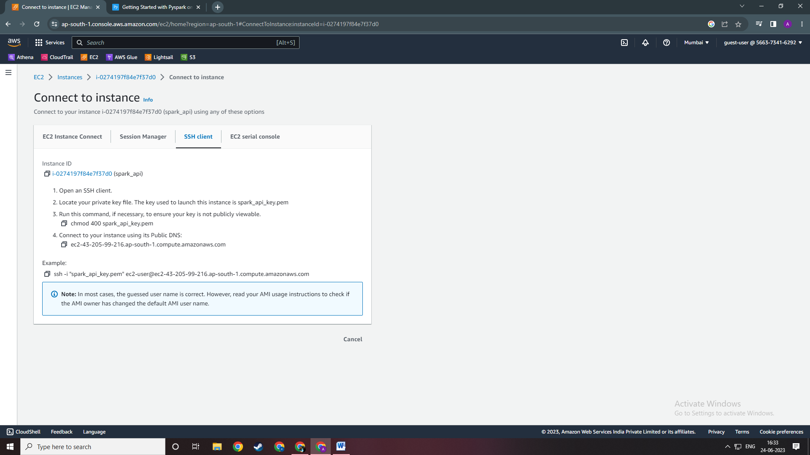

COPY the command under Example.   
ssh -i "spark_api_key.pem" ec2-user@ec2-43-205-99-216.ap-south-1.compute.amazonaws.com

Step 6. Open your command prompt and do in the directory in which you have store your pemp file using the “cd” command. Once you are into you same directory as your pem file paste the command you just copied.

After pressing enter, a question will prompt to add the host to your known_hosts file. Type **YES** .

This will help to recognize the host each time you’re trying to connect to your instance. And that’s it! Now you’re logged in on your AWS instance.   
  
If you get error saying not authorized user OR Permission denied and you can’t connect. Do the following steps.

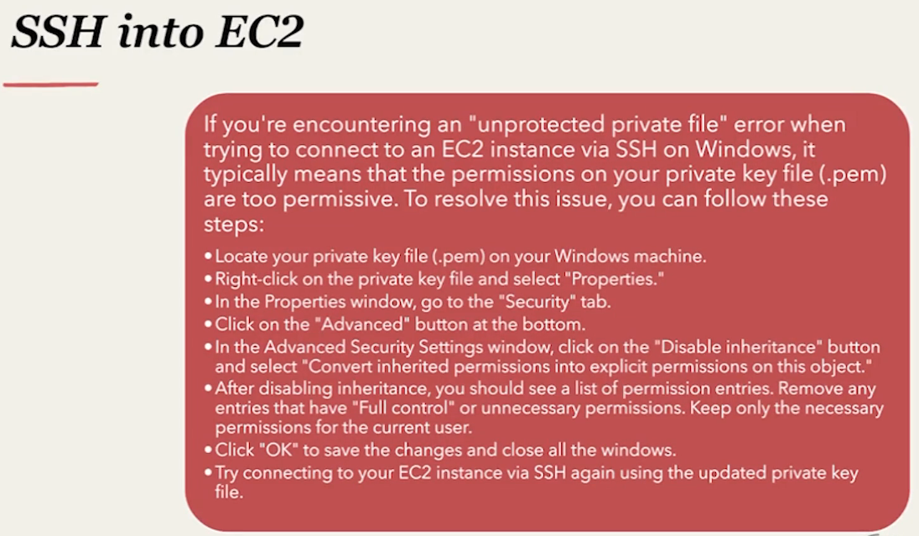

Only keep the user you currently are in the permission list.

Step 7. Once you are inside your EC2 instance run the Docker command from the Docker EC2 folder using the readme file   
  
AFTER COMPLETING THE Steps in readme.md file you should be able to run the docker commands   
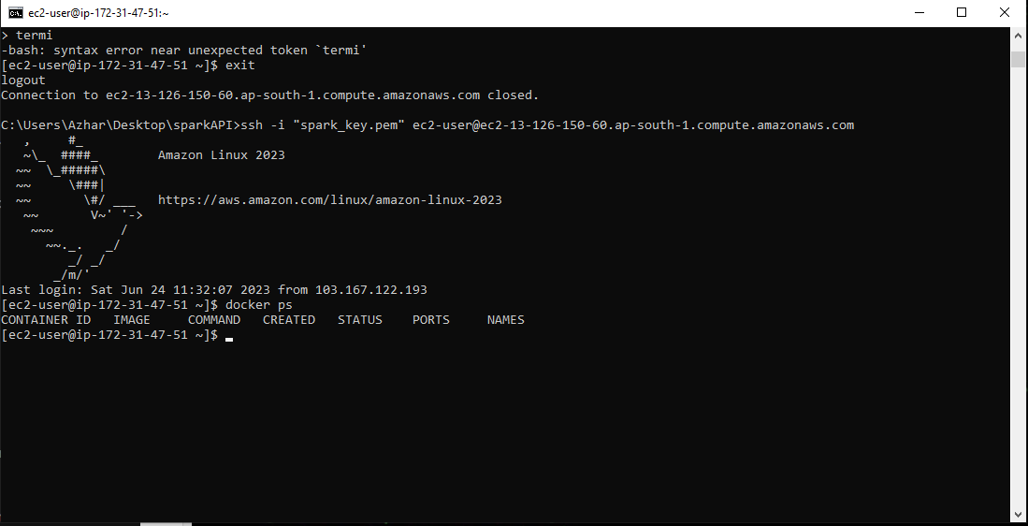

Step 8. Now that you have installed docker and have it up and running in your EC2 instance we need to add the DockerFile and the rest of the code files into our EC2 instance.